Week 4 Assignment
Integration Architecture Design- Part B

Scenario: Telecom operator migrating CRM, Billing and Network Monitoring to a central Lakehouse
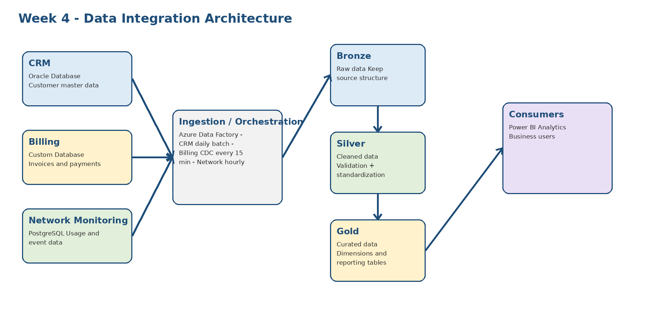
2. ETL vs ELT
Source | ETL vs ELT | Justification
CRM (Oracle) | ETL | Customer data needs basic cleaning and standardization before it is loaded into dim_customer.
Billing (Custom DB) | ELT | Billing changes arrive often. I will load the raw incremental data first, then transform it inside the Lakehouse.
Network Monitoring (PostgreSQL) | ELT | Network data can be high volume, so I will land it first and use Lakehouse processing for cleaning and aggregation.

3. CDC Strategy for the Billing System
For Billing, I will use a simple timestamp-based CDC approach. The source table should have a column such as last_updated. The pipeline stores the last processed timestamp. On the next run, it reads only records where last_updated is greater than the last processed timestamp. This means the pipeline only loads new or updated records instead of reading the full Billing table every time.
- Read the last processed timestamp.
- Extract new or updated Billing records after that timestamp.
- Load the records into the Bronze layer.
- Use MERGE/upsert in the Silver layer to update existing invoices and insert new invoices.
- Save the new processed timestamp only after the pipeline finishes successfully.
4.
- Idempotency
Idempotency means that if I run the same pipeline again, it should not create duplicate data. I will use unique business keys such as customer_id and invoice_id, and use MERGE/upsert instead of simple INSERT for incremental loads. I will also keep a batch ID and only mark a batch as completed after all steps succeed.
- Late-Arriving Data Handling
Some records may arrive after their expected time. I will use the event timestamp from the source data instead of only the load time. For Network data, the pipeline can reprocess a small recent window, for example the last 3 days. If an older record arrives late, it can still be placed in the correct date partition and included in the next Gold-layer refresh.
5. Orchestration Approach (DAG Scheduling)
I will use Azure Data Factory as the main orchestration tool. A simple DAG controls the order of the pipeline steps and makes sure downstream steps start only after upstream steps succeed.
Pipeline | Schedule | Steps | Dependency
CRM | Daily at 1:00 AM | Extract -> Clean -> Bronze/Silver -> dim_customer | Gold refresh waits for CRM success
Billing | Every 15 minutes | CDC extract -> Bronze -> MERGE Silver | Runs independently; Gold uses latest successful load
Network | Hourly | Extract -> Bronze -> Clean/Aggregate Silver | Gold refresh waits for hourly load when required
Gold / Reporting | Daily after source loads | Build curated tables -> quality checks | Runs after required source pipelines succeed

